
Regulations:
A14
Sreenidhi Institute of Science and Technology
(An Autonomous Institution)
Code No: 4A304 Date:5-Dec-16(FN)
B. TECH. II-Year I-Semester Examinations, Nov/Dec 2016 (Supplementary)
CIRCUITS & NETWORKS – II (EEE)

Time: 3 Hours Max. Marks: 70
Note: a) No additional answer sheets will be provided.
b) All sub-parts of a question must be answered at one place only, otherwise it will not be valued.
c) Assume any missing data.

Part - A
Max.Marks:20

Answer all QUESTIONS. EACH QUESTION CARRIES 2 MARKS.

1) | Write the expressions of wattmeter readings for measurement of three phase active power by two wattmeter method for a balanced three phase load. | [2M]
2) | What do you understand by transient and steady state parts of response. How they can be identified in a general solution? | [2M]
3) | Draw the series R-L circuit excited by a D.C. source and write the differential expression for the current in the circuit with waveform. | [2M]
4) | Write the restrictions on location of poles and zeros in driving point functions. | [2M]
5) | What are the necessary conditions for transfer functions | [2M]
6) | Write the expressions for Z-parameters in terms of Hybrid parameters in a Two port network. | [2M]
7) | What are the conditions of reciprocity and symmetry in Y-parameter representation. | [2M]
8) | What are the properties of filters. | [2M]
9) | The cut-off frequency of an LPF with RC configuration is 500Hz. Assuming R = 500Ω, find the value of C. | [2M]
10 | What are the properties of Fourier transforms. | [2M]

Part – B
Max.Marks:50

ANSWER ANY FIVE QUESTIONS. EACH QUESTION CARRIES 10 MARKS.

1 | a) | In a balanced delta-star connected circuit, V_{ab}=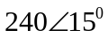V and Z_{Y} = (12+j15) Ω. Calculate the line currents. | [5M]
 | b) | Find the current supplied by 120V source using Star/Delta transformation.  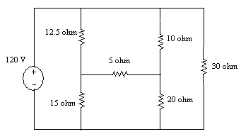 | [5M]
2 | a) | The switch has been in position A for a long time. At t = 0, the switch moves to B. Determine v(t) for t>0 and calculate its value at t = 1 sec and 4 sec.  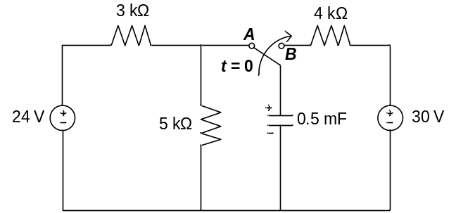 | [6M]
 | b) | Derive the transient response for the current in a series RLC circuit excited with a sinusoidal voltage source. | [4M]
3 | a) | Find the pole zero plots of the driving point and transfer impedances of the network shown in the figure.  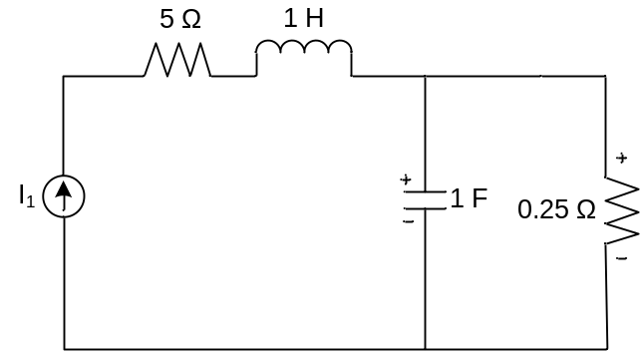 | [6M]
 | b) | Explain the significance of poles and zeros in a network function. What are the necessary conditions for driving point functions. | [4M]
4 | a) | Derive the conditions for reciprocity and symmetry in ABCD parameters of a two port network. | [5M]
 | b) | Obtain the Y-parameters for the T network shown below.  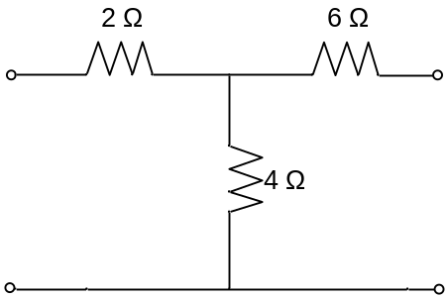 | [5M]
5 | a) | Design a constant-K low pass filter having cut-off frequency 2.5kHz and design resistance R_{o} = 700Ω. Also find the frequency at which this filter produces attenuation of 19.1dB. Find its characteristic impedance and phase constant at pass band and stop or attenuation band. | [6M]
 | b) | Write the classification of filters in an electrical network. | [4M]
6 | a) | A two mesh network is shown in the figure. Obtain the expression for I₁(s) and I₂(s) when the switch is closed.  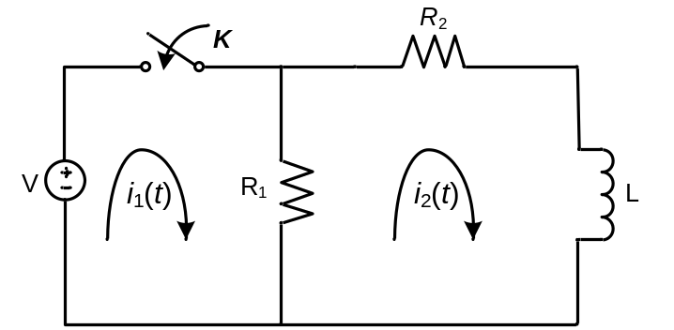 | [6M]
 | b) | Explain the exponential form of Fourier series. | [4M]
7 | a) | State and Prove Convolution property of Fourier Transform. | [6M]
 | b) | Find the fourier series of the single rectangular pulse shown in the figure.  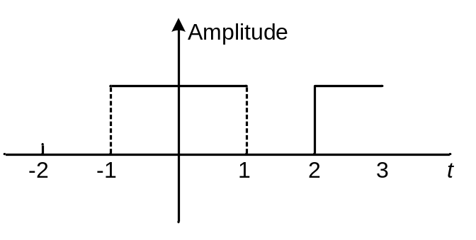 | [4M]
8. | a) | Explain the different types of interconnections of two port networks. | [6M]
 | b) | Derive the Y-parameters in terms of transmission parameters of a two-port network. | [4M]

-- 00 -- 00 --

